DAY-1 PROGRAMS:

1.Write a program to print Fibonacci series using recursion:

Program:

#include <stdio.h>

int fibonacci(int num)

{

if (num == 0)

{

return 0;

}

else if (num == 1)

{

return 1;

}

else

{

return fibonacci(num - 1) + fibonacci(num - 2);

}

}

void main()

{

int num;

printf("Enter the number of elements to be in the series : ");

scanf("%d", &num);

int i;

for (i = 0; i < num; i++)

{

printf("%d\n", fibonacci(i));

}

}

Output:

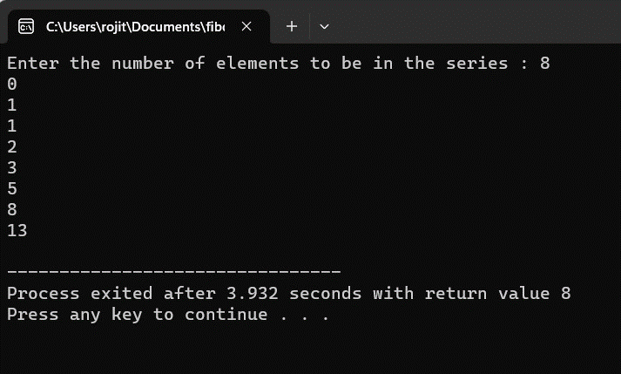

2.Write a program to check the given number is Armstrong or not:

Program:

#include<stdio.h>

int main()

{

int i,n,temp,sum=0,r;

printf("Enter 3 digit number:");

scanf("%d",&n);

temp=n;

while(n!=0)

{

r=n%10;

sum=sum+(r\*r\*r);

n=n/10;

}

if(temp==sum)

{

printf("%d is an Armstrong number",temp);

}

else

{

printf("%d is Not an Armstrong number",temp);

}

return 0;

}

Output:

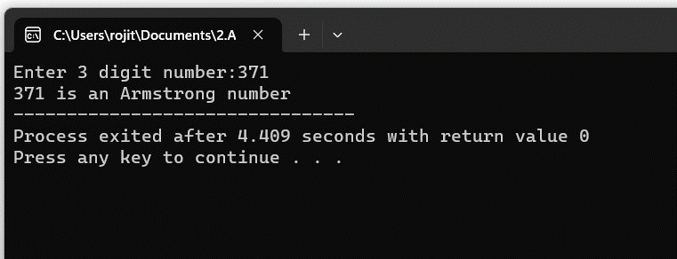

3.Write a program to find GCD of two numbers:

Program:

#include <stdio.h>

int main()

{

int n1, n2, i, gcd;

printf("Enter two integers: ");

scanf("%d %d", &n1, &n2);

for(i=1; i <= n1 && i <= n2; ++i)

{

if(n1%i==0 && n2%i==0)

{

gcd = i;

}

}

printf("G.C.D of %d and %d is %d", n1, n2, gcd);

return 0;

}

Output:

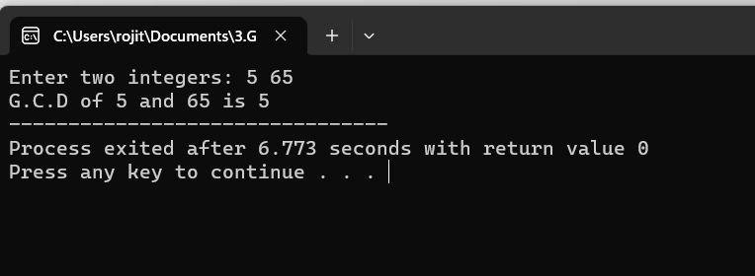

4.Write a program to get the largest element of an array:

Program:

#include <stdio.h>

int main()

{

int n,i;

int arr[20];

printf("Enter the number of elements: ");

scanf("%d",&n);

for (i=0;i<n;++i)

{

printf("Enter number%d: ",i+1);

scanf("%d",&arr[i]);

}

for (i=1;i<n;++i)

{

if (arr[0]<arr[i])

{

arr[0]=arr[i];

}

}

printf("Largest element = %d",arr[0]);

return 0;

}

Output:

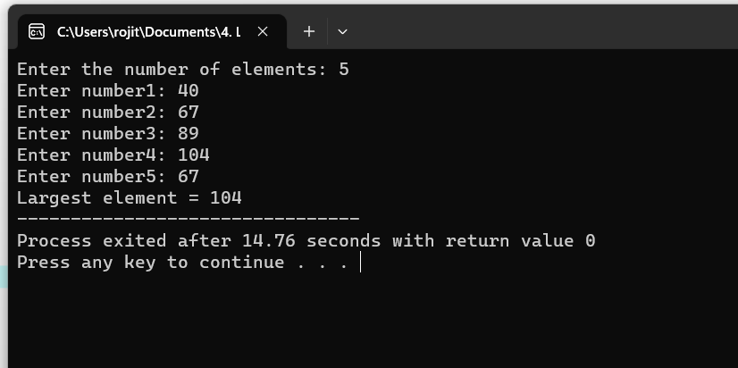

5.Write a program to find factorial of a number:

Program:

#include<stdio.h>

int main()

{

int i,n,fact=1;

printf("Enter any number:");

scanf("%d",&n);

if(n<0)

{

printf("No factorial for negactive numbers");

}

else if(n==0)

{

printf("0!=1");

}

else

{

for(i=1;i<=n;i++)

{

fact=fact\*i;

}

printf("%d!=%d",n,fact);

}

}

Output:

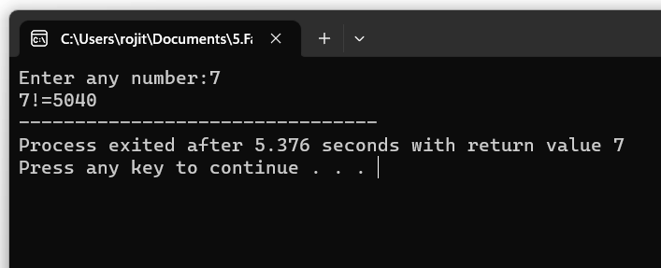

6.Write a program to check a number is prime number or not:

Program:

#include <stdio.h>

int main()

{

int n, i, flag = 0;

printf("Enter a positive integer: ");

scanf("%d", &n);

if (n==0||n==1)

{

flag=1;

}

for (i=2;i<=n/2;++i)

{

if (n%i==0)

{

flag=1;

break;

}

}

if (flag==0)

printf("%d is a prime number.",n);

else

printf("%d is not a prime number.",n);

return 0;

}

Output:

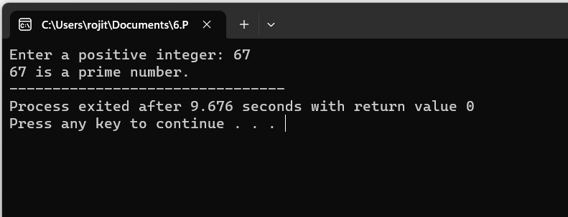

7.Write a program to perform Selection sort:

Program:

#include <stdio.h>

int main()

{

int array[100], n, c, d, position, t;

printf("Enter number of elements:");

scanf("%d",&n);

printf("Enter %d integers\n", n);

for (c = 0; c < n; c++)

{

scanf("%d", &array[c]);

}

for (c = 0; c < (n - 1); c++)

{

position = c;

for (d = c + 1; d < n; d++)

{

if (array[position] > array[d])

position = d;

}

if (position != c)

{

t = array[c];

array[c] = array[position];

array[position] = t;

}

}

printf("Sorted list in ascending order:\n");

for (c = 0; c < n; c++)

{

printf("%d\n", array[c]);

}

return 0;

}

Output:

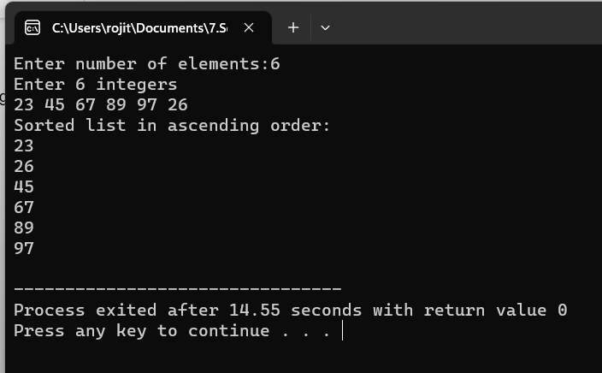

8.Write a program to perform Bubble sort:

Program:

#include<stdio.h>

int main()

{

int a[50],n,i,j,temp;

printf("Enter the size of array: ");

scanf("%d",&n);

printf("Enter the array elements: ");

for(i=0;i<n;++i)

{

scanf("%d",&a[i]);

}

for(i=1;i<n;++i)

{

for(j=0;j<(n-i);++j)

{

if(a[j]>a[j+1])

{

temp=a[j];

a[j]=a[j+1];

a[j+1]=temp;

}

}

}

printf("\nArray after sorting: ");

for(i=0;i<n;++i)

{

printf("%d ",a[i]);

}

return 0;

}

Output:

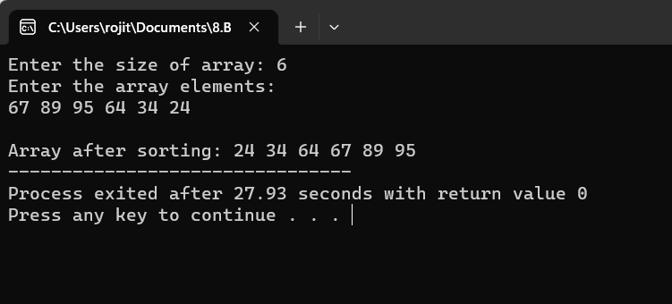

9.Write a program to Multiply two matrices:

Program:

#include<stdio.h>

int main()

{

int a[10][10], b[10][10], c[10][10], n, i, j, k;

printf("Enter the value of N : ");

scanf("%d", & n);

printf("Enter the elements of Matrix-A: \n");

for (i = 0; i < n; i++)

{

for (j = 0; j < n; j++)

{

scanf("%d", & a[i][j]);

}

}

printf("Enter the elements of Matrix-B: \n");

for (i = 0; i < n; i++)

{

for (j = 0; j < n; j++)

{

scanf("%d", & b[i][j]);

}

}

for (i = 0; i < n; i++)

{

for (j = 0; j < n; j++)

{

c[i][j] = 0;

for (k = 0; k < n; k++)

{

c[i][j] += a[i][k] \* b[k][j];

}

}

}

printf("The product of the two matrices is: \n");

for (i = 0; i < n; i++)

{

for (j = 0; j < n; j++)

{

printf("%d\t", c[i][j]);

}

printf("\n");

}

return 0;

}

Output:

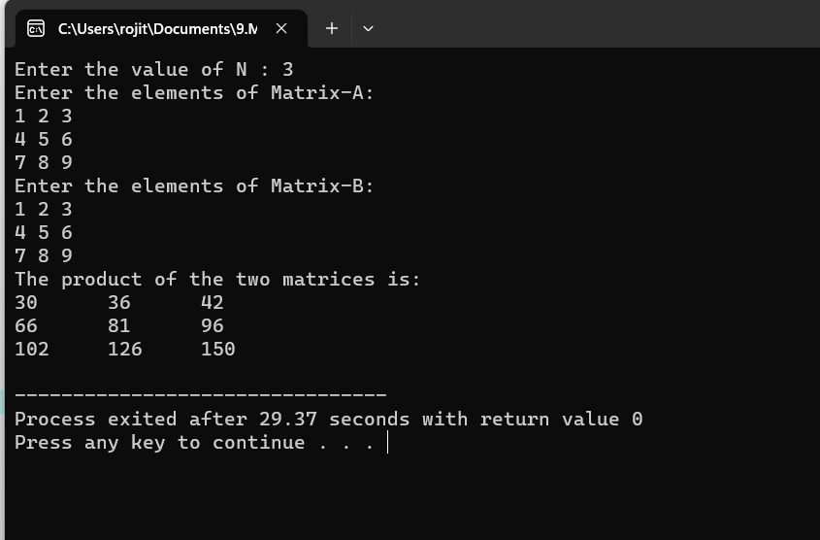

10.Write a program to check whether a given String is Palindrome or not:

Program:

#include <stdio.h>

#include <string.h>

int main()

{

char string1[20];

int i, length;

int flag = 0;

printf("Enter a string:");

scanf("%s", string1);

length = strlen(string1);

for(i=0;i < length ;i++)

{

if(string1[i] != string1[length-i-1])

{

flag = 1;

break;

}

}

if (flag)

{

printf("%s is not a palindrome", string1);

}

else

{

printf("%s is a palindrome", string1);

}

return 0;

}

Output:

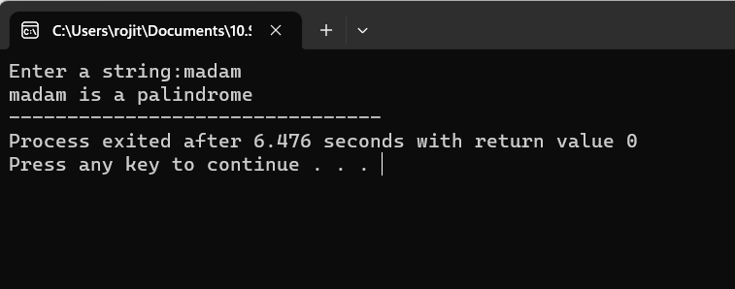

11. Write a program to Copy one string to another:

Program:

#include <stdio.h>

int main()

{

char s1[1000],s2[1000];

int i;

printf("Enter any string: ");

gets(s1);

for(i=0;s1[i]!='\0';i++)

{

s2[i]=s1[i];

}

s2[i]='\0';

printf("original string s1='%s'\n",s1);

printf("copied string s2='%s'",s2);

return 0;

}

Output:

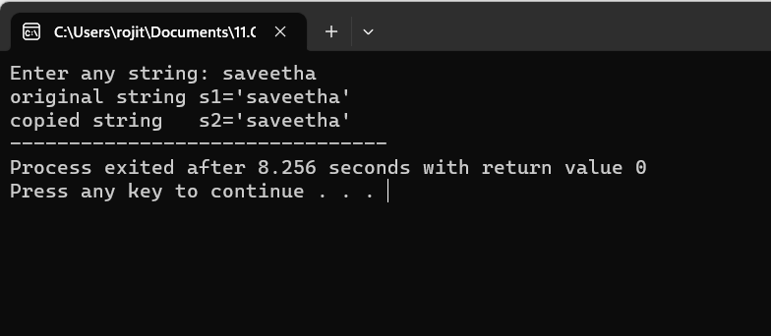

12.Write a program to perform Binary Search:

Program:

#include <stdio.h>

int main()

{

int c, first, last, middle, n, search, array[100];

printf("Enter number of elements:");

scanf("%d", &n);

printf("Enter %d integers:\n", n);

for (c = 0; c < n; c++)

scanf("%d", &array[c]);

printf("Enter value to find;\n");

scanf("%d", &search);

first = 0;

last = n - 1;

middle = (first+last)/2;

while (first <= last) {

if (array[middle] < search)

first = middle + 1;

else if (array[middle] == search) {

printf("%d found at location %d.\n", search, middle+1);

break;

}

else

last = middle - 1;

middle = (first + last)/2;

}

if (first > last)

printf("Not found! %d isn't present in the list.\n", search);

return 0;

}

Output:

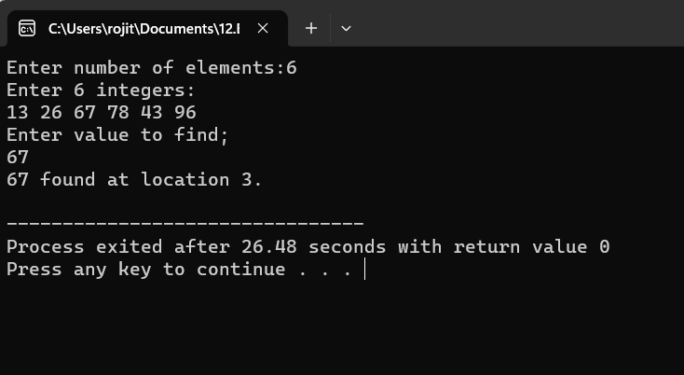

13. Write a program to print the Reverse of a string:

Program:

#include <stdio.h>

#include <string.h>

int main()

{

char str[50];

printf("Enter the string:");

gets(str);

printf("After reversing string is =%s", strrev(str));

return 0;

}

Output:

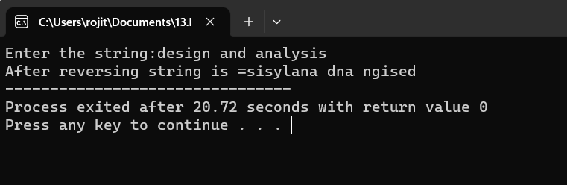

14.Writw a program to find the length of a string:

Program:

#include<stdio.h>

#include<string.h>

int main()

{

char s[20];

int i;

printf("Enter a string:");

gets(s);

for (i = 0; s[i] != '\0'; i++);

printf("Length of the string: %d", i);

return 0;

}

Output:

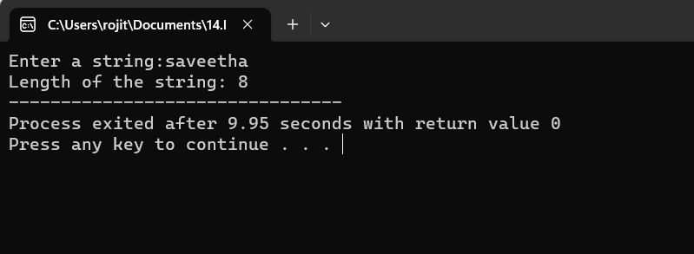

15.Write a program to perform Strassen’s Matrix Multiplication:

Program:

#include<stdio.h>

int main()

{

int a[2][2], b[2][2], c[2][2], i, j;

int m1, m2, m3, m4 , m5, m6, m7;

printf("Enter the 4 elements of first matrix: ");

for(i = 0;i < 2; i++)

for(j = 0;j < 2; j++)

scanf("%d", &a[i][j]);

printf("Enter the 4 elements of second matrix: ");

for(i = 0; i < 2; i++)

for(j = 0;j < 2; j++)

scanf("%d", &b[i][j]);

m1= (a[0][0] + a[1][1]) \* (b[0][0] + b[1][1]);

m2= (a[1][0] + a[1][1]) \* b[0][0];

m3= a[0][0] \* (b[0][1] - b[1][1]);

m4= a[1][1] \* (b[1][0] - b[0][0]);

m5= (a[0][0] + a[0][1]) \* b[1][1];

m6= (a[1][0] - a[0][0]) \* (b[0][0]+b[0][1]);

m7= (a[0][1] - a[1][1]) \* (b[1][0]+b[1][1]);

c[0][0] = m1 + m4- m5 + m7;

c[0][1] = m3 + m5;

c[1][0] = m2 + m4;

c[1][1] = m1 - m2 + m3 + m6;

printf("\nAfter multiplication using Strassen's algorithm \n");

for(i = 0; i < 2 ; i++){

printf("\n");

for(j = 0;j < 2; j++)

printf("%d\t", c[i][j]);

}

return 0;

}

Output:

